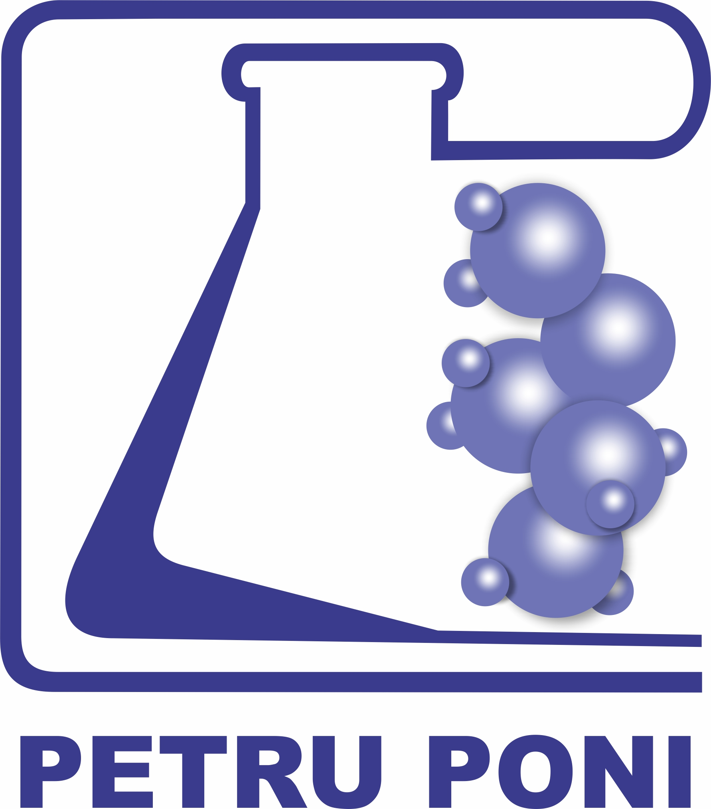 | ROMANIAN ACADEMY  “PETRU PONI” INSTITUTE OF MACROMOLECULAR CHEMISTRY  41A Grigore Ghica Voda Alley, 700487 IAȘI, ROMANIA  Tel. +40.332.880220; E-mail: pponi@icmpp.ro
Approved
Legal representative,
dr. Valeria HARABAGIU

.....................................

COMPETITION ANNOUNCEMENT

As the Beneficiary, the “Petru Poni” Institute of Macromolecular Chemistry Iaşi, organizes the competition to hire within the funding contract no. 73TE ⁄ 03.01.2025, “Bio-based magnetically susceptible organic-inorganic hybrid/composite materials for effective wastewater treatment”, Acronim: BioHyClean, Code: PN-IV-P2-2.1-TE-2023-1830, several vacancies, as follows:

The position of Research Assistant (Member - PhD student):
Number of positions open to competition: 1
Type of employment contract: Individual part-time employment contract (20 hours/month)
Estimated contract start date: 03.03.2025
Employment period: temporary, until 31.12.2026, with funding from “Bio-based magnetically susceptible organic-inorganic hybrid/composite materials for effective wastewater treatment” project, funding contract no. 73TE ⁄ 03.01.2025
The place of the research activity: Laboratory 6: Inorganic Polymers within the “Petru Poni” Institute of Macromolecular Chemistry
Place of the competition: “Petru Poni” Institute of Macromolecular Chemistry (ICMPP), 41A Grigore Ghica Voda Alley, 700487 Iași

Specific requirements for the Research Assistant position (Member - doctoral student):
Job description: Characterization of complex systems based on carbon nanostructures through in silico studies
• The candidate must be a graduate of higher education, holding a bachelor's and master's degree in one of the fields of chemistry/chemical engineering, and must be enrolled in a doctoral program in chemistry or chemical engineering at a doctoral school;
• The candidate's doctoral thesis topic must be in the field of (nano)magnetic composites;
• Proven experience in the synthesis of spinel ferrites (un)doped with rare earth elements;
• Experience in obtaining magnetic composite materials based on polysaccharides through ionotropic gelation;
• Experience in conducting adsorption experiments of organic and/or inorganic pollutants;
• Ability to interpret experimental results obtained through techniques such as TEM, XRD, VSM, FTIR, and UV-Vis;
• The candidate must have skills in processing and presenting experimental results;
• Intermediate knowledge of the English language (mandatory); knowledge of other international languages is an advantage;
• The candidate must be willing to travel nationally and internationally;
• Must be motivated and creative, with advanced communication and teamwork skills;
• Must possess practical knowledge of computer operation (Word, Excel, PowerPoint, Origin).

Selection procedure:
- Analysis of the candidate's file (eliminatory step) - Lack of a requested document or failure to fulfill a mandatory requirement entails elimination from the competition. The results of the selection of competition files are displayed on the ICMPP website with the mention „admitted” or „rejected”;
- Written test (eliminatory) – The written test will take place at the ICMPP headquarters and will consist of a written exam with subjects according to the examination topics displayed on the website. Only candidates who have submitted all the necessary documents to register for the competition and meet the conditions for participation are accepted to participate in the written test. To be declared admitted, candidates must obtain a minimum grade of 8 (eight) in the written test. The results of the written test are displayed on the ICMPP website with the mention „admitted” or „rejected”;
- Oral examination - The oral examination will take place at the ICMPP headquarters and will consist of the presentation of the scientific activity of the candidates. To be declared admitted, candidates must obtain a minimum grade of 8 (eight) in the oral test. The results of the oral examination are displayed on the ICMPP website with the mention „admitted” or „rejected”.
The result of the competition tests is appreciated by each member of the commission with grades from 1 to 10; the grade of the test represents the arithmetic average of the grades given by the committee members.
The final mark of the candidates is calculated as follows:
final grade = written exam grade x 0.7 + oral exam grade x 0.3
The ranking of candidates will be done according to the final average.

Examination topics:
- Synthesis of (nano)magnetic particles (spinel ferrites);
- Doping ferrites with rare earth elements;
- Characterization of magnetic compounds through X-ray diffraction, infrared spectroscopy, vibrating sample magnetometry, and transmission electron microscopy;
- Synthesis of composite materials (beads) through ionotropic gelation;
- Physicochemical and magnetic characterization of composite materials;
- Adsorption processes under static and dynamic conditions (kinetics, isotherms, thermodynamics).
Bibliography:
1. O. F. Călţun, Ferite de cobalt magnetostrictive, Editura Universitaţii “Alexandru Ioan Cuza” Iaşi, 2008
2. Q. Hong et al., Spinel ferrites (MFe₂O₄): Synthesis, improvement and catalytic application in environment and energy field, Advances in Colloid and Interface Science 294 (2021) 102486.
3. A. Vedrtnam et al., A comprehensive study on structure, properties, synthesis and
characterization of ferrites, AIMS Materials Science, 7(6): 800–835 (2020).
4. S. Yadav et al., Adsorption of cationic dyes, drugs and metal from aqueous solutions using a polymer composite of magnetic/β-cyclodextrin/activated charcoal/Na alginate: Isotherm, kinetics
and regeneration studies, Journal of Hazardous Materials, 409, 124840 (2021).
5. Samoila, P., Humelnicu, A.-C., Ignat, M., Cojocaru, C., Harabagiu, V. Chitin and Chitosan for Water Purification, in Chitin and Chitosan: Properties and Applications, First Edition, edited by Van den Broek, L.A.M., Boeriu, C.G., John Wiley & Sons Ltd, 2020, 429–460.

Note: This position is open to all candidates regardless of their nationality, gender, religion, race or sexual orientation, the project team rejects any type of discrimination.

Competition timetable:
Competition publication date: 16.01.2025
Deadline for file submission: 17.02.2025, at 10.00 at the ICMPP headquarters or online at: humelnicu.andra@icmpp.ro
Publication of the results of the files analysis: 17.02.2025, at 16.00
Deadline for appeals of the results of the files analysis: 18.02.2025, at 14.00
Publication of the final results of the file analysis: 18.02.2025, at 16.00
Written test date: 19.02.2025, at 10.00
Date of publication of the results of the written test: 20.02.2025, at 16.00
Deadline for appeals of the results of the written test: 21.02.2025, at 14.00
Date of publication of the results of the written test: 21.02.2025, at 16.00
Oral examination: 24.02.2025, at 11.00
Date of publication of the results of the oral examination: 24.02.2025, at 16.00
Deadline for appeals of the results of the oral examination: 25.02.2025, at 14.00
Publication of the final results of the oral examination: 25.02.2025, at 16.00
Publication of the final results of the competition on the institute website: 26.02.2025, at 15.00

General requirements for candidates:
• The candidate has proficiency in Romanian and/or English;
• •The candidate has full exercise capacity;
• The candidate has a health condition suitable for the position they are applying for;
• The candidate meets the specific requirements for the position for which he/she is applying.

The enrolment file must contain:
- The candidate must submit a formal request addressed to the ICMPP management by which he requests the registration in the competition for filling the vacant position, dated and signed by the candidate, approved by the director of the institute and registered within the legal registration deadline
- Copy of identity document and copies of documents certifying the change of name, if applicable;
- Copies of the documents certifying the candidate's studies: bachelor's and/or master's degree accompanied by the transcript (academic reports or diploma supplement);
- Diplomas obtained in other states must be recognized by the National Council for Attestation of University Titles, Diplomas and Certificates (CNATDCU);
- Certificate attesting the quality of doctoral student enrolled in an institution organizing doctoral studies in Romania;
- Annex 9 – Agreement of the doctoral supervisor (model displayed on the website) filled and signed;
- Curriculum vitae adapted to employment requirements;
- Cover letter (free format) in which to indicate the research areas of interest and the motivation for applying for the position;
- Medical certificate in original, attesting clearly the state of health, the number, date, name of the issuer and its quality, in the standard format established by the Ministry of Health;
- Criminal record or declaration on his own responsibility that he/she has no criminal convictions that would make him/her incompatible with the position for which he/she is applying, with the completion of the competition file (up to the date of the first competition test) with the original criminal record

The candidate undertakes to maintain the confidentiality of the research topics in which he/she participates.

Details regarding the specific conditions can be read on the website https://icmpp.ro, <<Vacancies>> Section, https://www.euraxess.gov.ro/ro, https://jobs.research.gov.ro/, or additional information can be obtained at the Human Resources Office at the headquarters of the “Petru Poni” Institute of Macromolecular Chemistry from Iasi, telephone 0332 880 220, as well as at e-mail: humelnicu.andra@icmpp.ro.

This announcement was published on the Institute’s website - <<Vacancies>> Section, by the Secretary of the competition commission on 16.01.2025

